Ideation Phase
Define the Problem Statements

Date | 18 June 2026
Project Name | ShopEZ

In today’s fast-paced digital marketplace, customers expect online shopping platforms to provide convenience, transparency, and trust. However, many users struggle with inconsistent product information, unclear pricing, and complicated checkout processes. These challenges lead to frustration, abandoned carts, and reduced customer loyalty. Sellers, on the other hand, face difficulties managing orders efficiently and analyzing sales performance due to limited dashboard insights.
ShopEZ aims to bridge this gap by creating a unified, user-friendly e-commerce platform that simplifies product discovery, ensures secure transactions, and empowers sellers with robust analytics. By focusing on intuitive design, seamless navigation, and reliable backend architecture, ShopEZ seeks to deliver a shopping experience that is effortless, transparent, and satisfying for both customers and sellers.
.

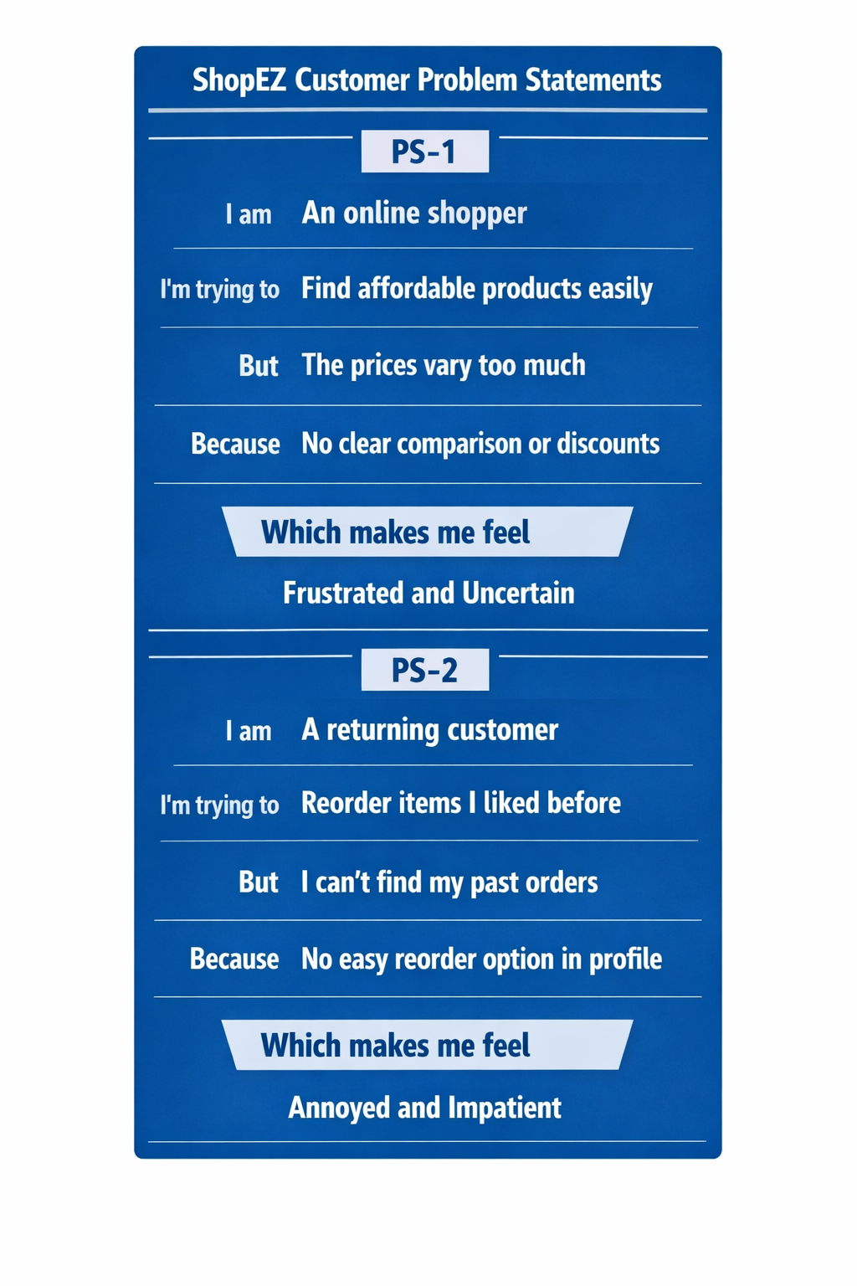

Problem Statement (PS) | I am (Customer) | I'm trying to | But | Because | Which makes me feel
PS-1 | An online shopper | Find affordable products easily | The prices vary too much across listings | There’s no clear comparison or discount visibility | Frustrated and uncertain
PS-2 | A returning customer | Reorder items I liked before | My previous orders are hard to locate | The profile section lacks quick reorder options | Annoyed and impatient
PS-3 | A new user | Complete my first purchase | The checkout process feels complicated | Too many steps and unclear payment options | Confused and hesitant
PS-4 | A busy professional | Buy products quickly during breaks | The site loads slowly and shows irrelevant ads | Poor optimization and cluttered interface | Irritated and discouraged

